**Submitted by:**

Navdeep Kaur Gill

300772906

**Submitted to:**

Mr.Carmen



|  |  |
| --- | --- |
| **Table of Contents** | **Page No** |
| Brief Description | 2 |
| Nav Bar | 2 |
| Colors | 3 |
| Typography | 3 |
| Wireframes | 4 |
| Branding | 7 |

1. **Brief Description**

In my website , there are six pages namely; Home , About Me , Projects , Services , GitHuB ,Contact page and Login Page. Homepage describes about me in which I add slider which shows my previous work. In this, I also add tagline and Mission. It is followed by About me Page in which I add CV and my profile picture. Service page illustrates about the services provided by my company .In last page that is Contact page which manifests the contact information related to me .Moreover, it also shows the links of social networking sites i.e. facebook, gmail, yahoo, twitter and youtube. There is also one page GitHub page in which I post my website on that software. In Login Page, it fetches information from database. In all pages, there is common functionality of logo, navbar and copyright.

1. **Navbar**

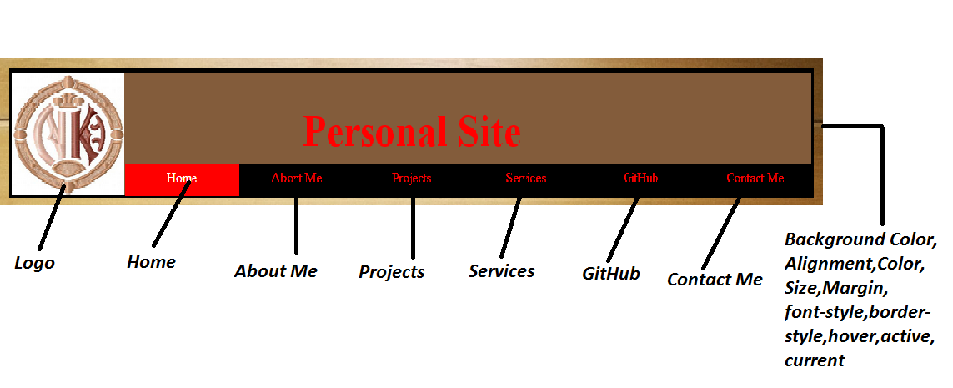

**Updated NavBar**

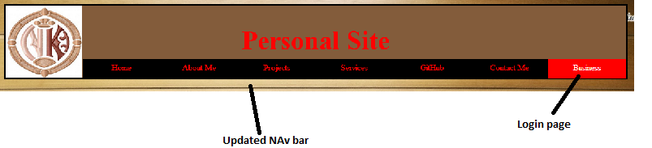

1. **Colors**

|  |  |  |
| --- | --- | --- |
| **Color Names** | **Swatches** | **Hexadecimal Values** |
| White |  | #FFFFFF |
| Dark moderate yellow |  | #835C3B |
| Black |  | #000000 |
| Red |  | #FF0000 |
| Very soft yellow |  | #F3E2A9 |
| Very dark gray |  | #2a2a2a |

1. **Typography**

**Home Page**

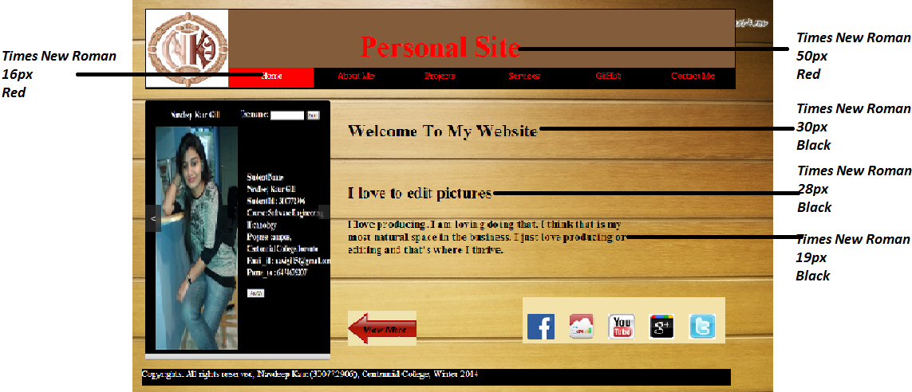

|  |  |  |
| --- | --- | --- |
| **Font-Family** | **Font-Size** | **Font-Color** |
| Times New Roman | 50px | Red |
| Times New Roman | 16px | Red |
| Times New Roman | 30px | Black |
| Times New Roman | 28px | Black |
| Times New Roman | 19px | Black |

1. **Wireframes**

**Home Page**

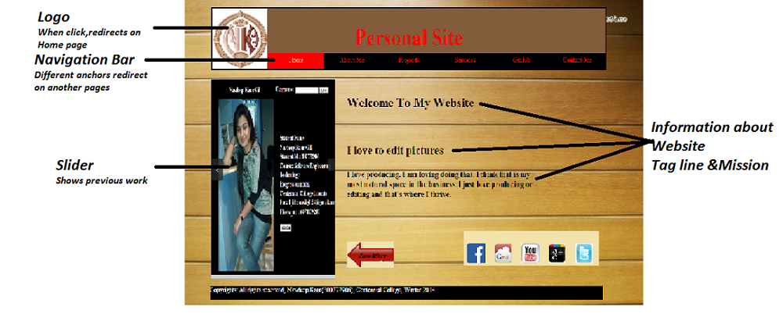

**About Me**

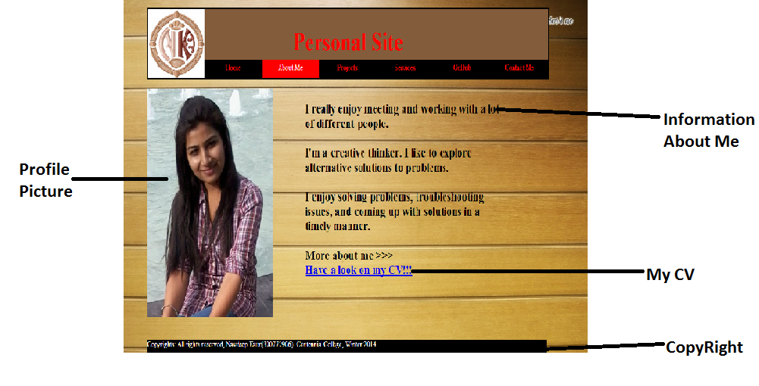

**Projects**

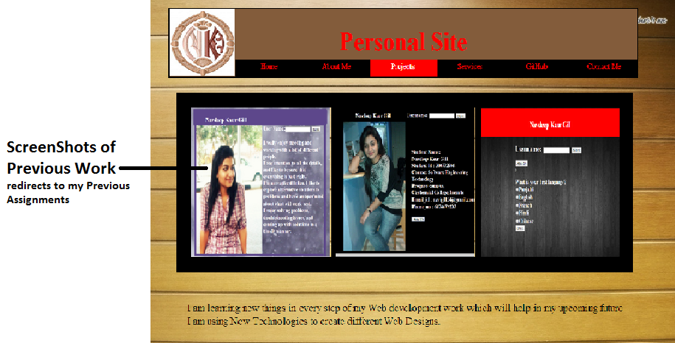

**Services**

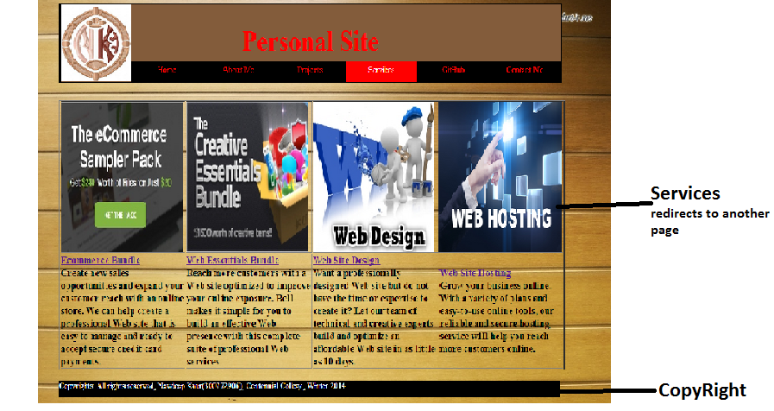

**ContactMe**

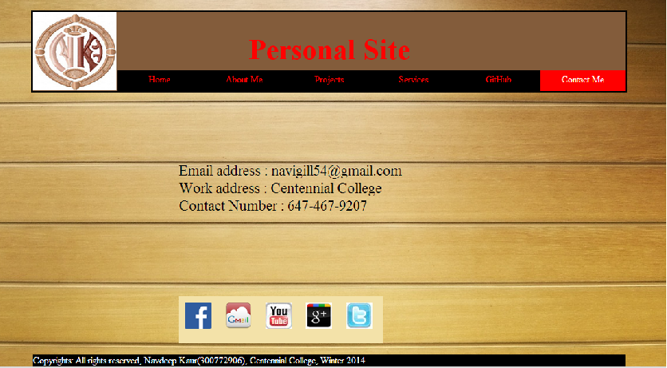

**Login Page**

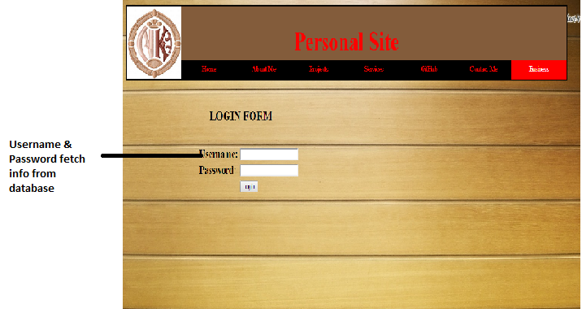

1. **Branding**

**Home**

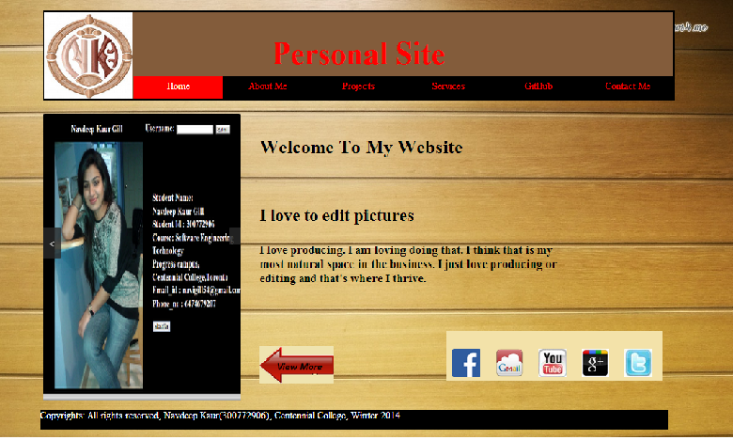

**Contact Me**

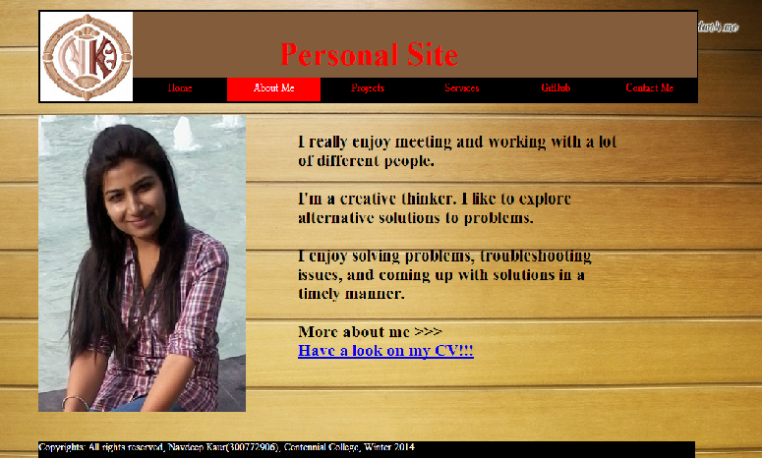

**Projects**

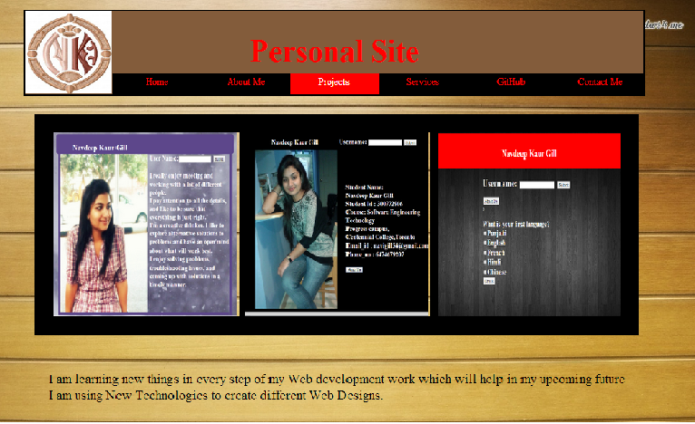

**Services**



**Contact Me**



**Login Page**

